Module 4 – Question 2
Question Name: Find Digits
Platform: HackerRank
Programming Language: C
Problem URL: https://www.hackerrank.com/challenges/find-digits/problem
Problem Statement
An integer is a divisor of another integer if the remainder is zero when the second integer is divided by the first.
Given an integer, for each digit that makes up the integer, determine whether it is a divisor. Count the number of divisors occurring within the integer.
Function Description
Complete the findDigits function.
findDigits has the following parameter:
- int n: the value to analyze.
Returns:
- int: the number of digits in n that are divisors of n.
Input Format
- The first line contains an integer T, the number of test cases.
- The next T lines each contain an integer N.
Constraints
- As given in the original HackerRank problem.
Sample Input
2
12
1012
Sample Output
2
3
Explanation
The number 12 contains digits 1 and 2. Both divide 12 evenly, so the answer is 2.
The number 1012 contains digits 1, 0, 1 and 2. Digits 1, 1 and 2 divide 1012 evenly. Zero is ignored because division by zero is undefined. Therefore, the answer is 3.
Code Screenshot
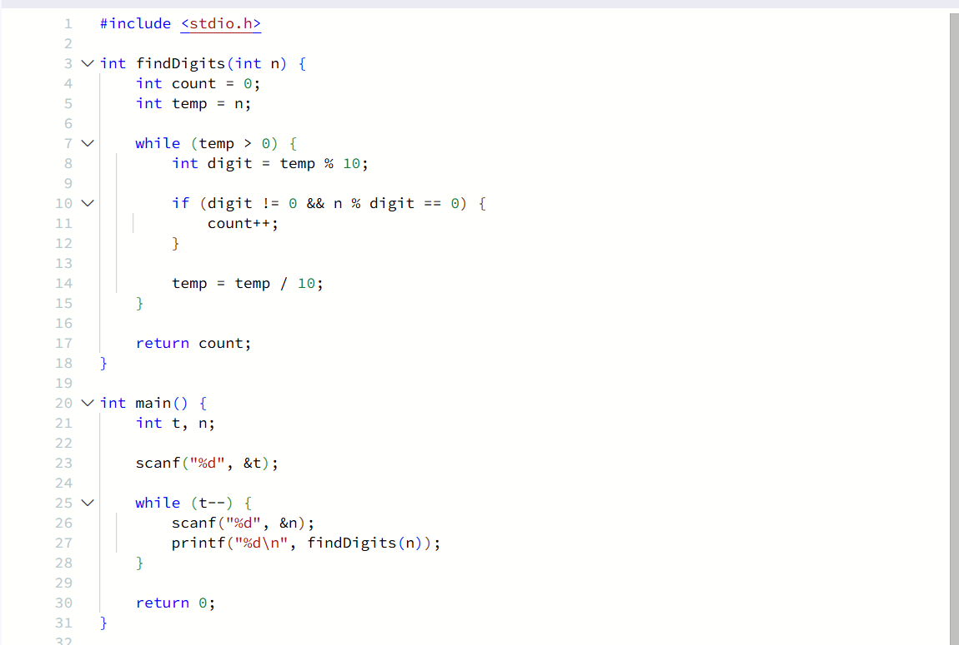Output Screenshot
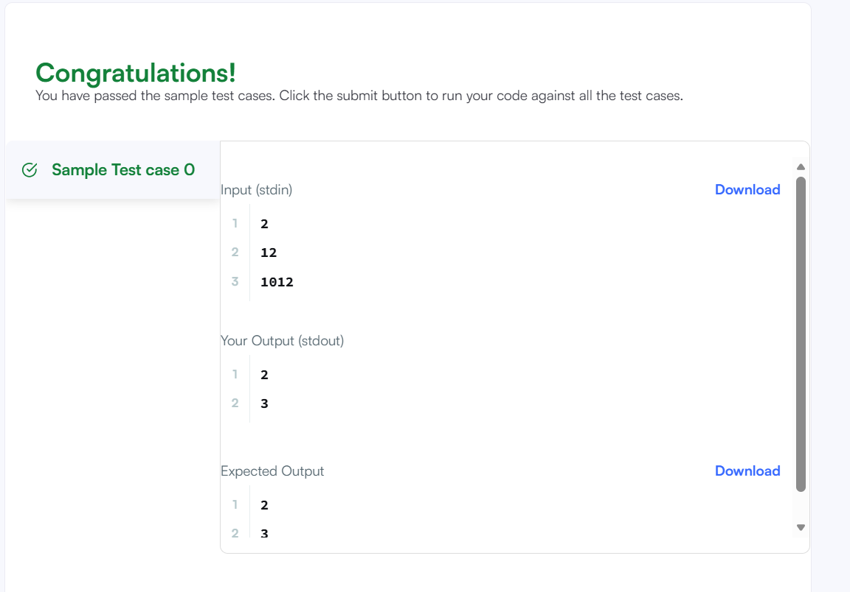
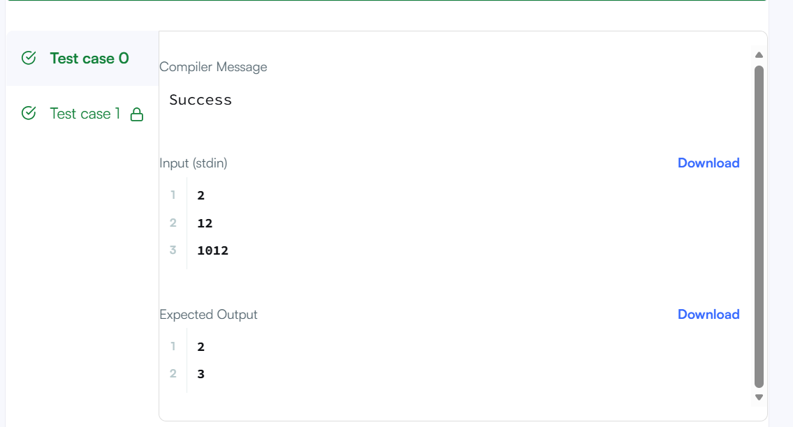Result
The program was executed and submitted on HackerRank.

